Assignment-3

Student Name | VIDDY VIRSTANDI P.A.P
Unit Number and Title | ACWD Module 4 – Database Design & Implementation
Academic Year | 2022
Unit Assessor | Arvinder Kaur
Project Title | Implement a Database Design for Community Portal
Issue Date | 03-08-2022
Submission Date | 03-08-2022
Internal Verifier Name

Learner declaration
I certify that the work submitted for this assignment is my own and research sources are fully acknowledged.

Student signature: Date: 03-08-2022

Submission Format
- Screen Capture of Sample Data for Report
- Queries for generating reports from database
- Detailed Description of Test Methods
- Documentation of database
The scope of this assignment
- Create test data for all tables suitable for generating reports
- Design report and create queries which will be used for generation of meaningful management reports. Present the report in HTML format (1 report)
- Discuss briefly test methods you will employ to test and validate the database and brief reason why choose each test
- Document database
- Create a batch script to backup database & schedule it to run every 6 hours using windows task scheduler. Provide the script, along with the screen capture of Windows Task Scheduler
- Provide a Restoration script in case of failure

- Create test data for all tables suitable for generating reports
Table | user
SQL Query | INSERT INTO user  (username,password,email)  VALUES  (‘ ’, ‘Viddy01’,’123456’,’viddy@email.com’.),  (‘ ’, ‘Mahmud05’,’123456’,’mahmud@email.com’.),  (‘ ’, ‘Jas0n’,’123456’,’jason@email.com’.),  (‘ ’, ‘Ncull07’,’123456’,’ncull@email.com’.),  (‘ ’, ‘Amir08’,’123456’,’cypher@email.com’.),  (‘ ’, ‘HanSunWoo’,’123456’,’jett@email.com’.),
Id | username | password | email
1 | Viddy01 | 123456 | viddy@email.com
2 | Mahmud05 | 123456 | mahmud@email.com
3 | Jas0n | 123456 | jason@email.com
4 | Ncull07 | 123456 | ncull@email.com
5 | Amir08 | 123456 | cypher@email.com
6 | HanSunWoo | 123456 | jett@email.com

 | admin
SQL Query | INSERT INTO admin  (username,password,email,gender)  VALUES  (' ' ,'gede', '12345', 'gede@gmaul.com', 'male',),  (' ' ,'Ncull17', '21213', 'ncull@gmail.com', 'male',),  (' ' ,'arief', '22334', 'arief@gmail.com', 'male',),  (' ' ,'savina01', '01013', 'savina@gmail.com', 'female',),  (' ' ,'nurhaliza', '89789', 'nur05@gmail.com', 'female',),
Id | username | password | email | Gender
1 | gede | 12345 | gede@gmaul.com | Male
2 | Ncull17 | 21213 | ncull@gmail.com | Male
3 | Arief | 22334 | arief@gmail.com | Male
4 | safira01 | 01013 | savina@gmail.com | Female
5 | nurhaliza | 89789 | nur05@gmail.com | Female

- Design report and create queries which will be used for generation of meaningful management reports.

No | Note | Query | Evidence
1 | All user,company info.  To fetch users, company information | -- creating reporting categories using the Cartesian product  SELECT  company.id_company AS id_company,  company.company_name,  company.company_desc,  user.user_id AS user_id,  user.user_name  FROM company, user; | Report user and company log

Report user and company log
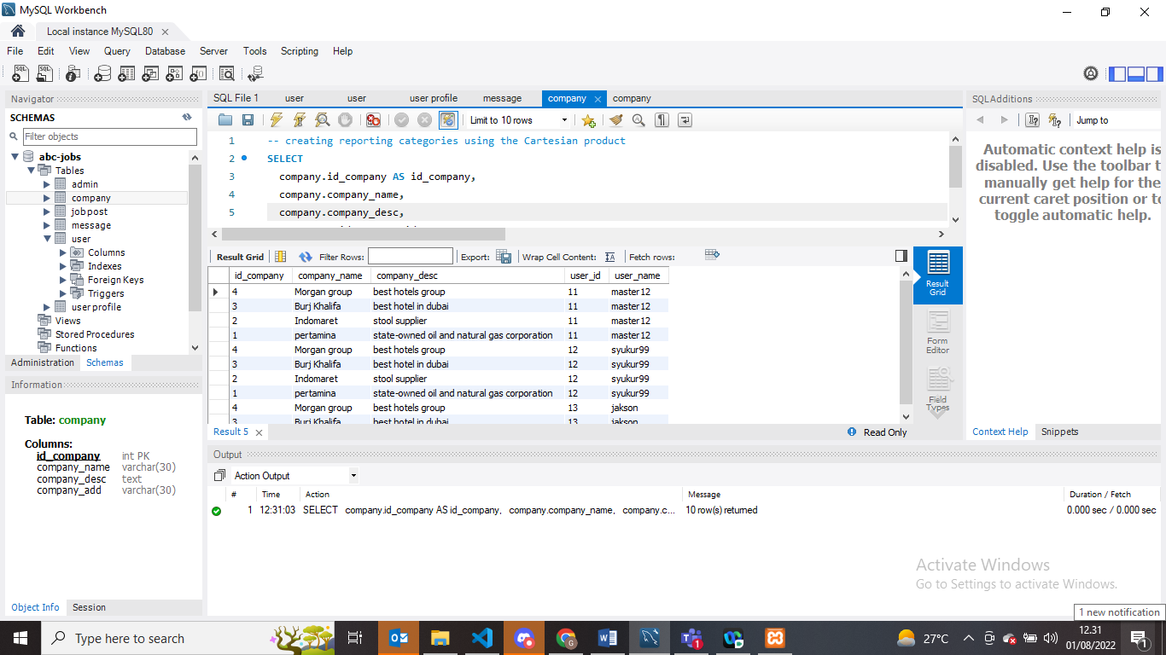

- Discuss briefly test methods you will employ to test and validate the database and brief reason why choose each test

- Structural Database Testing

  - Schema Testing.
Schema is one of database testing is where used for ensuring the validity of data received and stored into database.

In this test case i testing relationship primary key and foreign key for table_company and Table_job post. In this cas all job post will have foreign key from which company that offer job vacancies.
No. / Test Cases | Expected Result | Actual Result | Test Result | Evidence
Test A01  To Ensure Relationship Schema (table name, attributes, primary key and foreign key) in databases | Should be has relationship beetween Tb_company and Tb_job post because connected with PK and Fk | has relationship beetween Tb_company and Tb_job post | Pass | Screen capture on schema relationship on below

Evidence:
Relationship Schema in this testing
all jobs post should be have id_company from which that post job vacancies
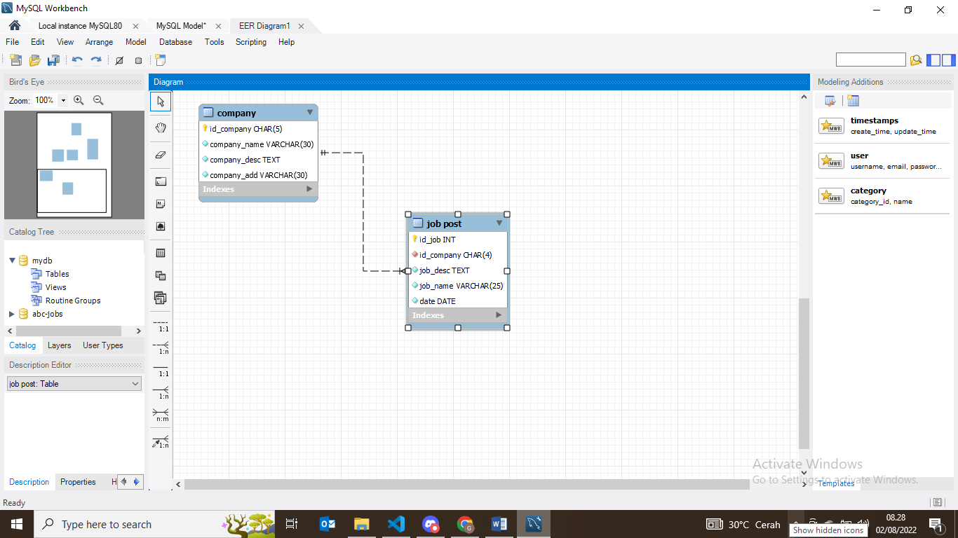

This is schema relationship in databases abc-jobs
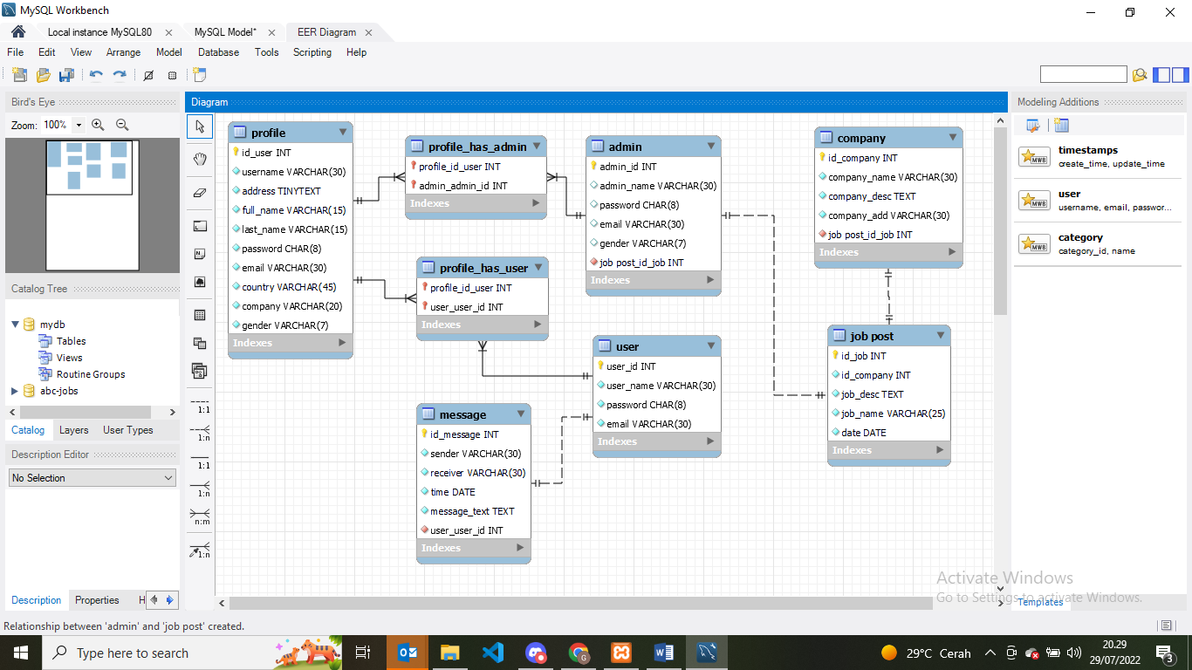

Company list primary key id_company.

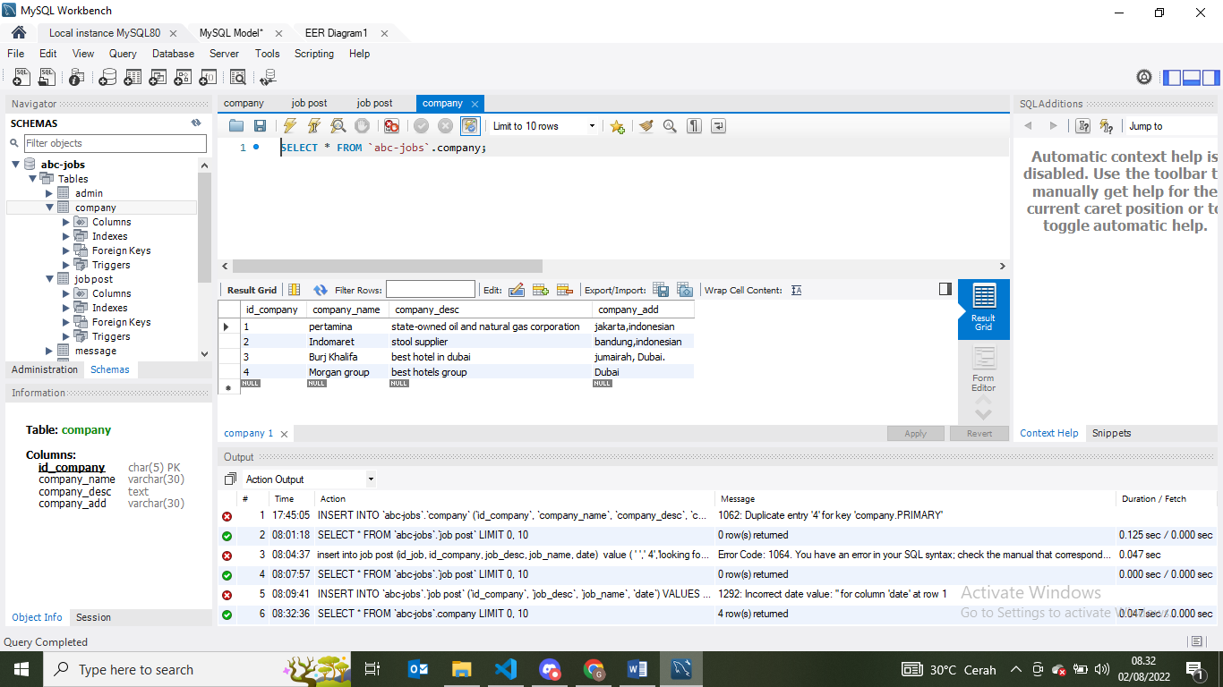

Insert into job post table with jobs vacancies from foreign key id_company 3

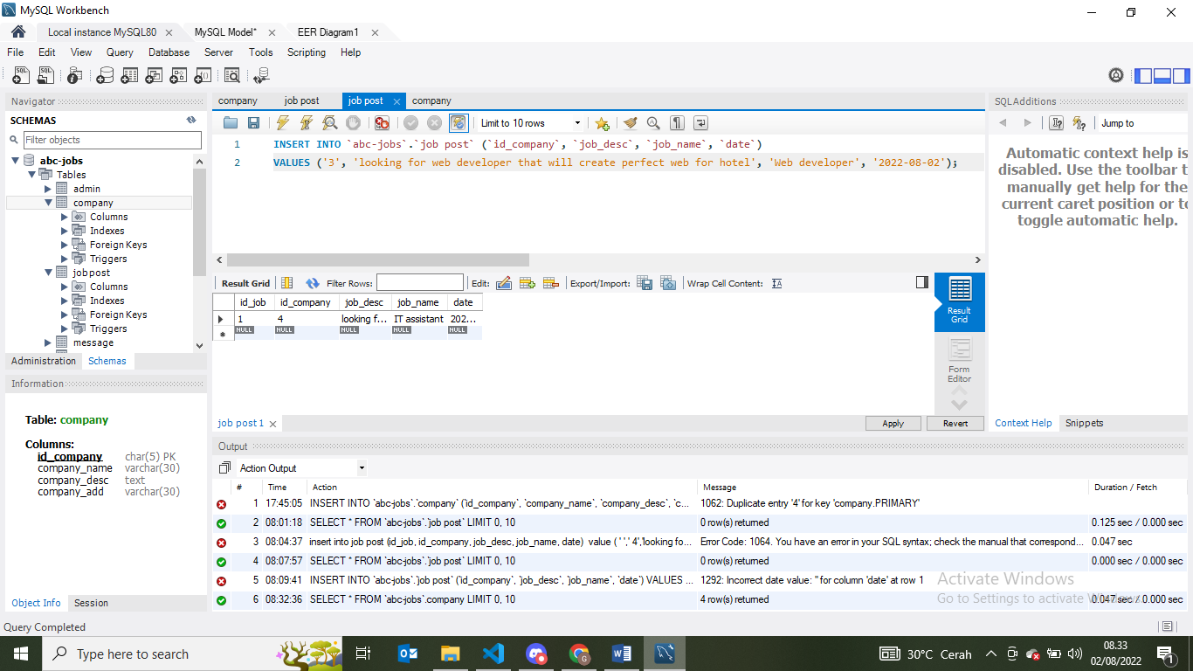

Job vacancies allready insert in job post table with foreign key id_company from company table.

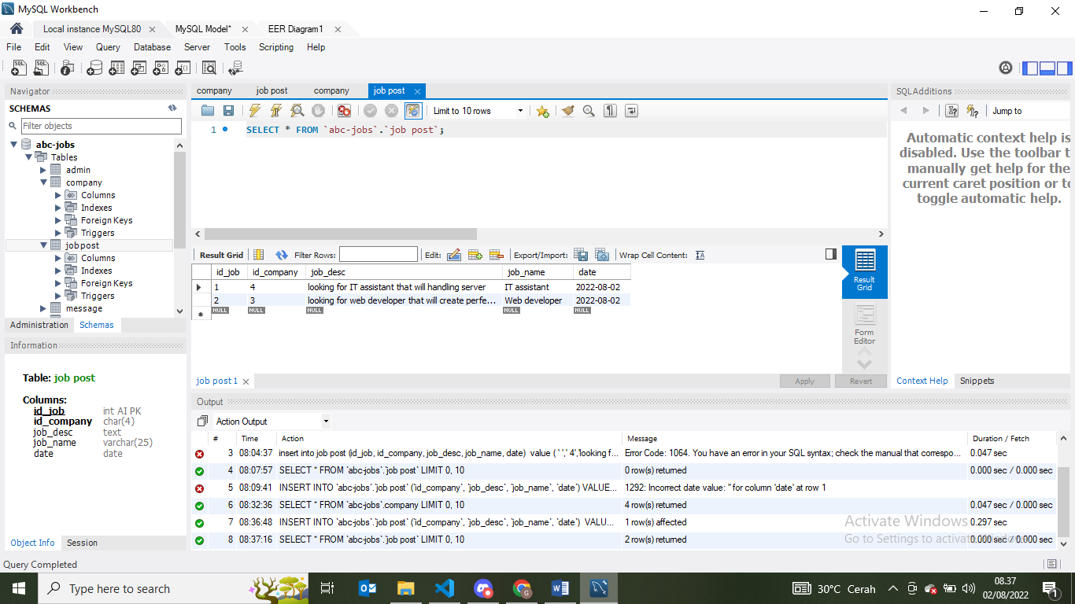

  - Table/column primary key testing.
Sql will not allowed if input the duplicate value.
Table/columns primary key testing
TestCase ID | Test case | Expected result | Actual result | Pass / Fail | Evidence
TC01 | 1. Primary Key testing: Insert duplicate value for primary key column for ‘company’ table | Error message will appear because there is duplicate entry Primary key | Error message appear because there duplicate entry primarykey | Pass | Evidence screen capture No TC01

Test TC01= input duplicate primary key (4)
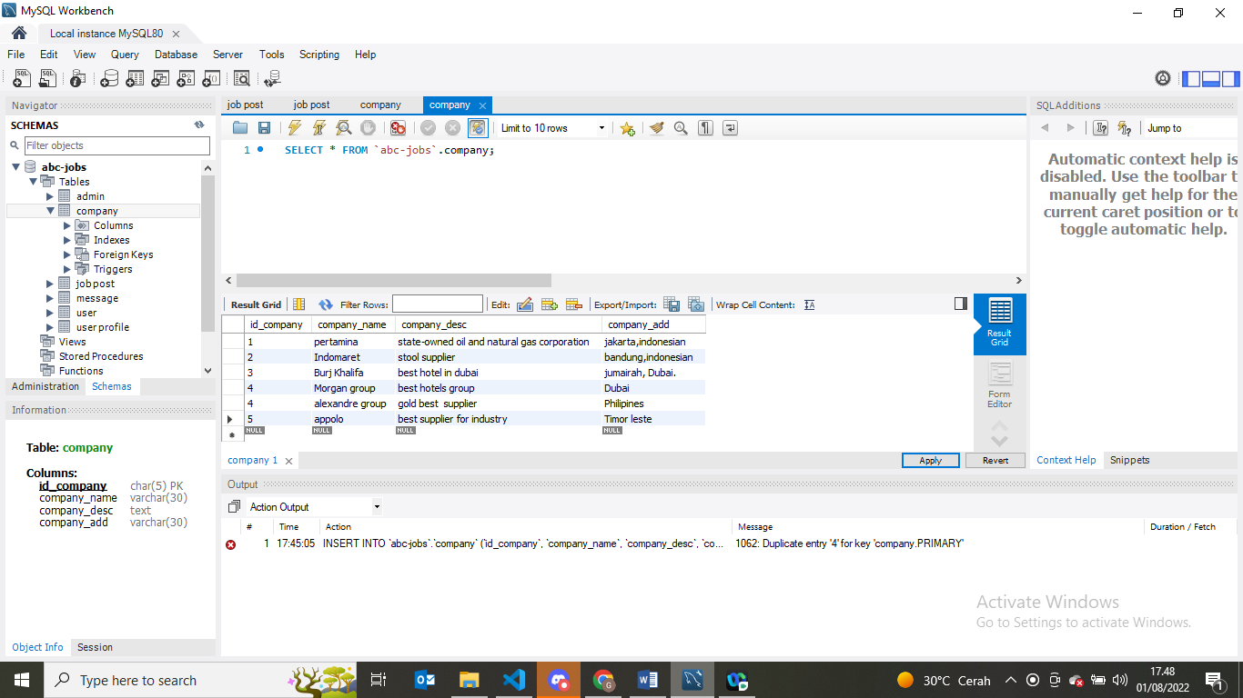
Error Message appear


- Functional Database Testing
Functional database testing is to test whether data in the database can be access and updated by the users and applications. all CRUD
TestCase ID | Test Case | Expected Result | Actual Result | Test Result | Evidence
T01 | 1. Insert record into ‘admin’ table | A record should successfully insert into 'admin' table. | Record is successfully inserted into ‘admin’ table | Pass | FC01 Fig

Evidence: -
FC01
Querry
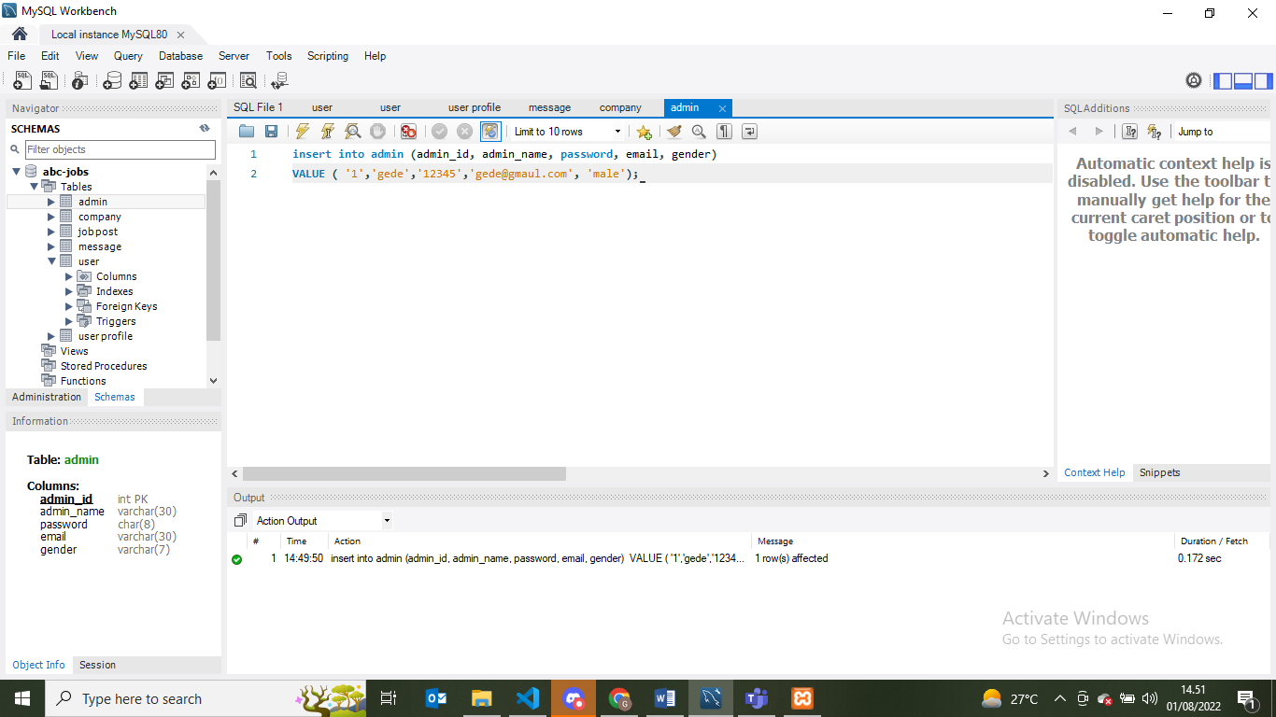
Data has been success insert

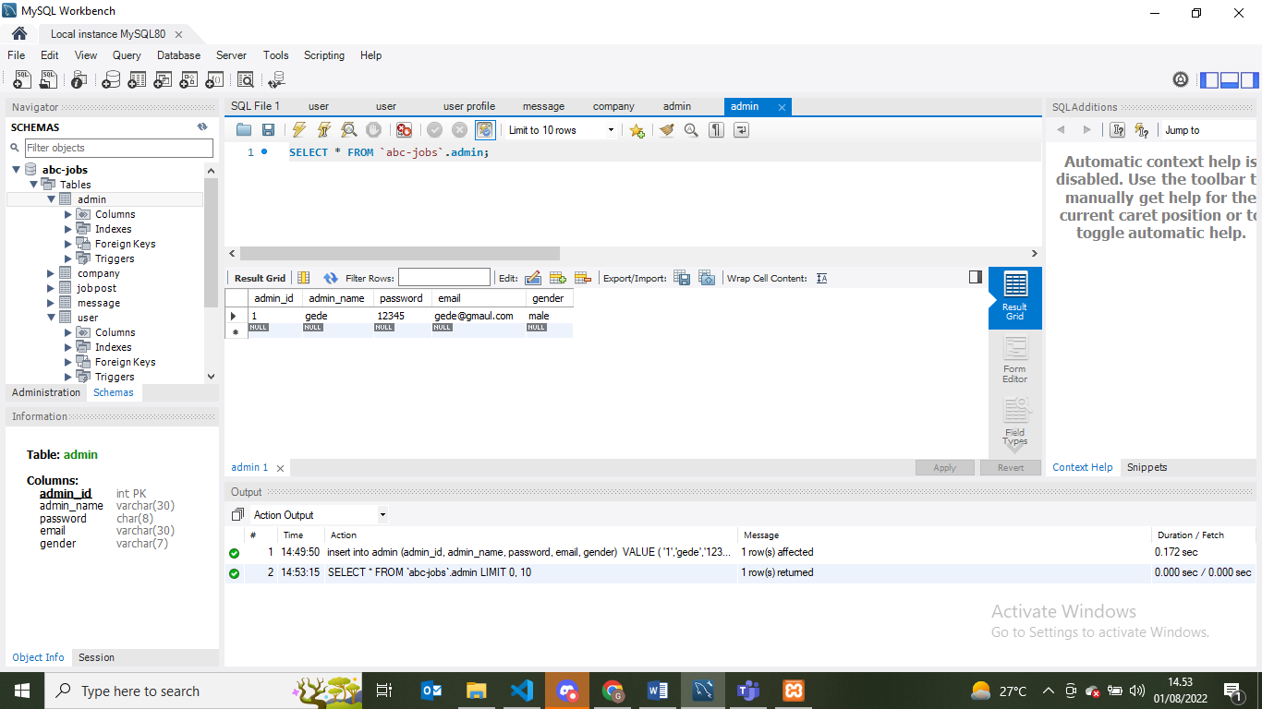

- Document Database
Abc Database
Entity Name | Table Name
User | Tb_user  Field Name Field Type Size  user_name varchar 30  password char 8  user_id (fk) int 5  email_address varchar 30
Profile | Tb_user-profile  Field Name Field Type Size  user_name varchar 30  user_id(Pk) int 5  address text 30  email varchar 30  age int 3  gender varchar 7  company varchar 20  first_name varchar 15  last_name varchar 15  country varchar 20
Admin | Tb_admin  Field Name Field Type Size  admin_id (pk) int 5  admin_name varchar 30  email varchar 30  password char 8  gender varchar 7
Job Post | Tb_job post  Field Name Field Type Size  Id_jobs (pk) int 5  date_post DATETIME 15  Id_company(fk) int 5  jobs_desc TEXT 100  jobs_name varchar 25
Message | Tb_message  Field Name Field Type Size  Id_sender int 5  Id_receiver int 5  message_text varchar 1000  date DATE 20  Id_massage(pk) int 5
Company | Tb_company  Field Name Field Type Size  company_id(pk) int 5  company_name varchar 30  company_desc TEXT 1000  company_address varchar 30
Thread | Tb_Thread  Field Name Field Type Size  thread_id(pk) int 5  date DATE 20  thread_desc TEXT 1000  comment TEXT 1000

Index
No. | Field | Primary key | Foreign key
- user_profile | user_name  Id_user(Pk)  address  email  age  gender  company  first_name  last_name  country | Id_user | 1.user_id (from table user)  2.admin_id (from admin user)
- company | Field Name  company_id  company_name  company_desc  company_address | Company_id | 1.id_company (from table job post)
- message | Id_sender(fk)  Id_receiver(fk)  message_text  date  Id_massage(pk) | Id_massage | 1.id_sender(from table user)  2.id_receiver(from table user)

- Create a batch script to backup database & schedule it to run every 1 minutes using windows task scheduler. Provide the script, along with the screen capture of Windows Task Scheduler .

- Backup batch file
Backup abc –jobs databases to directory C:\backup is success
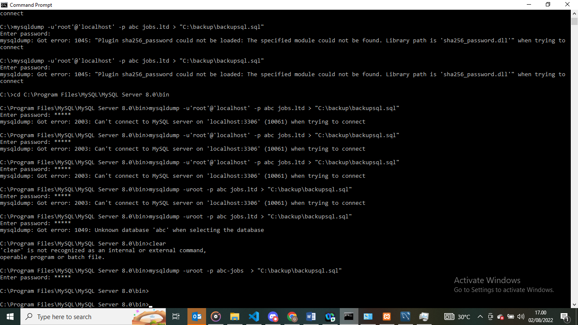

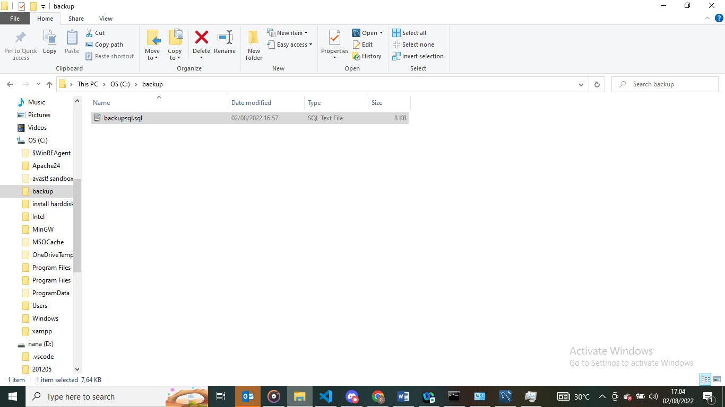

Databases that has been backup
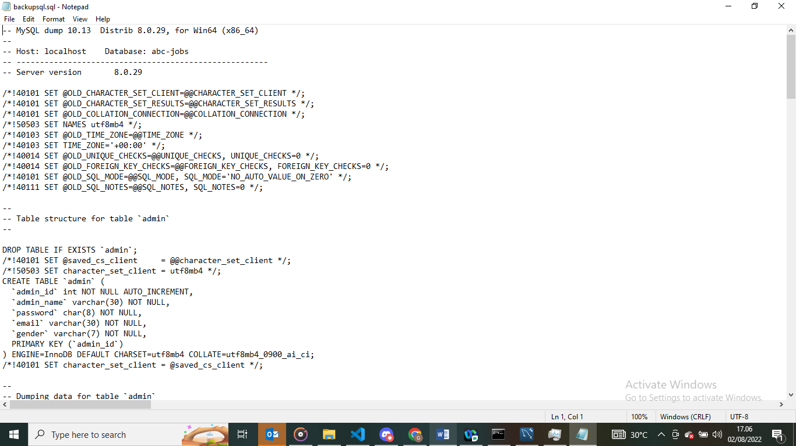

Test with task scheduler
Create bat file that will use for testinng
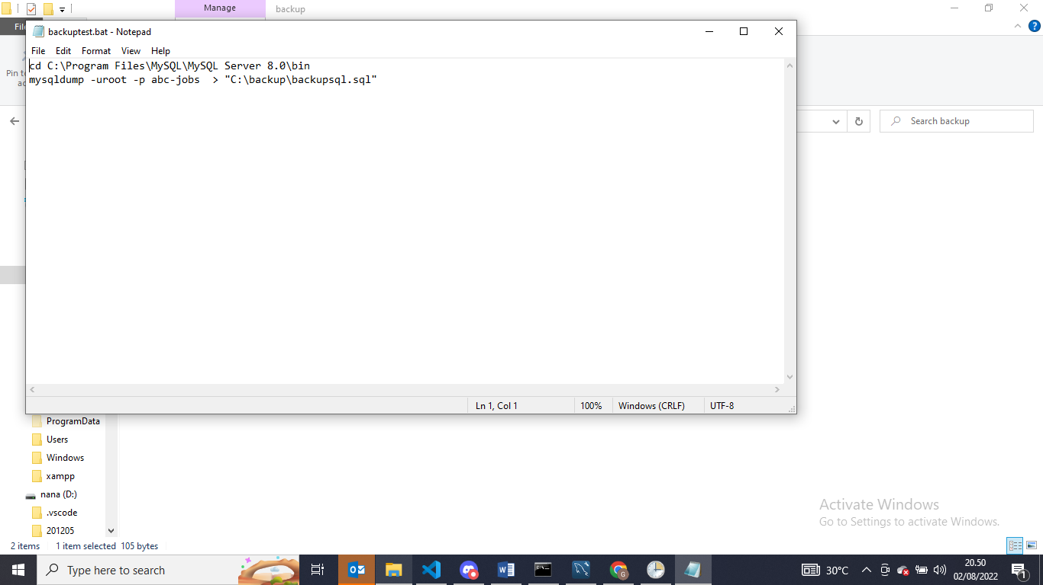

- Setting the windows task scheduler
- Create task name
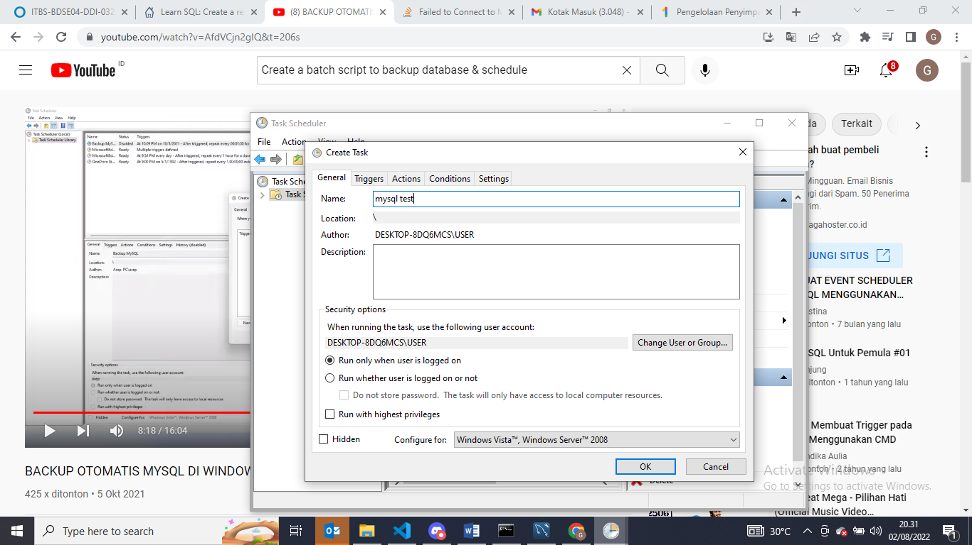
- Setting triggers with 1 minutes test run
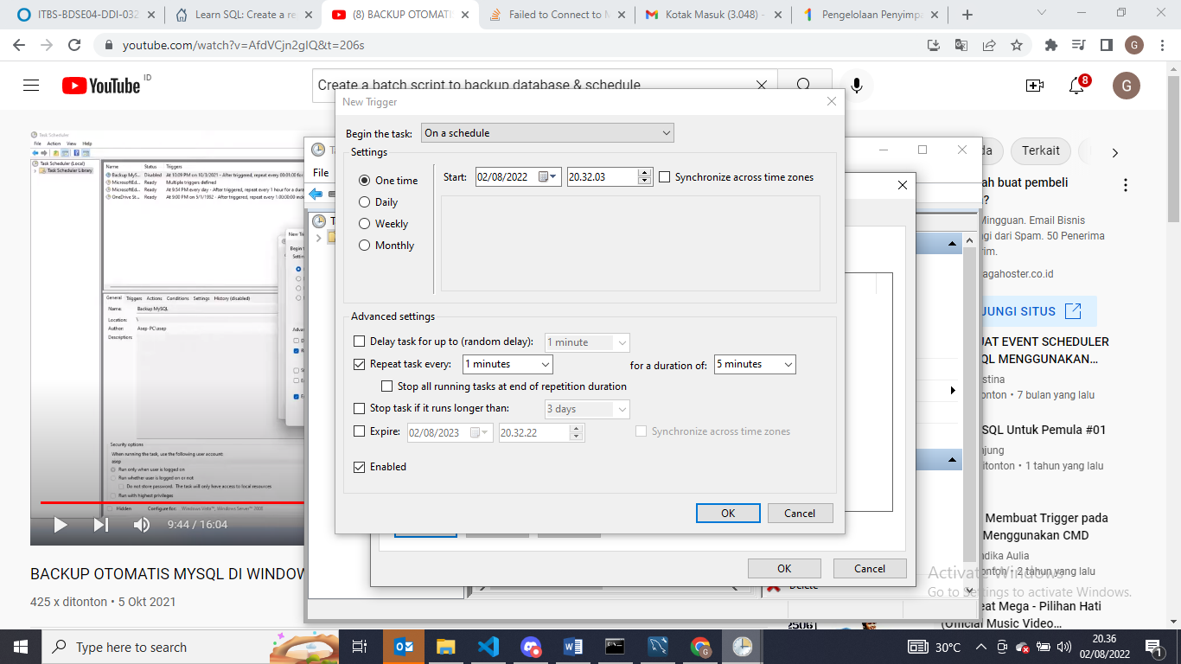
- Setting action with choose which bat file that want to test with browse it
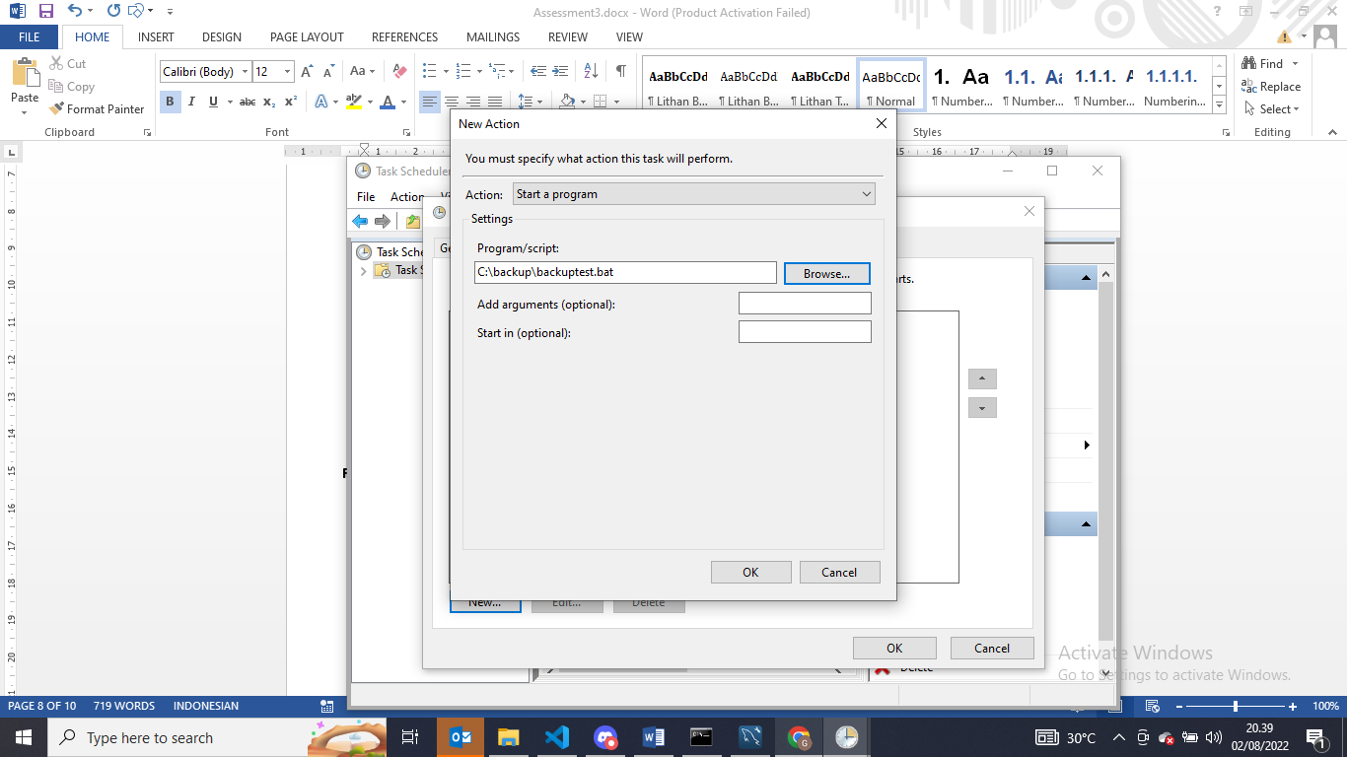
The file success to test with windows task scheduler is allready appear with 1 minutes setting test
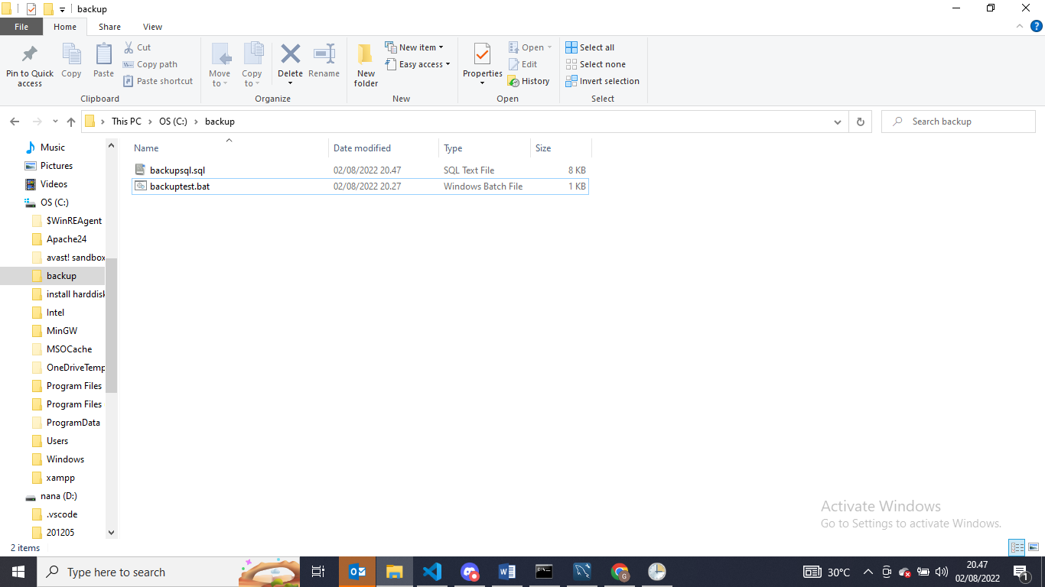

- Provide a Restoration script in case of failure

This is script that provide in cas of failure. This script will restore the batch file.
